Bushra Nasser

900221024

Report on Assignment 4 CS2

The first part is writing a program that takes from the user *n* integers and stores them in a vector of int.

Afterward, I created a function insertAfterthat takes *firstValue* and *secondValue*.

The purpose of this function is it search for each occurrence of *firstValue* in the vector and insert the *secondValue* next; the user enters the values.

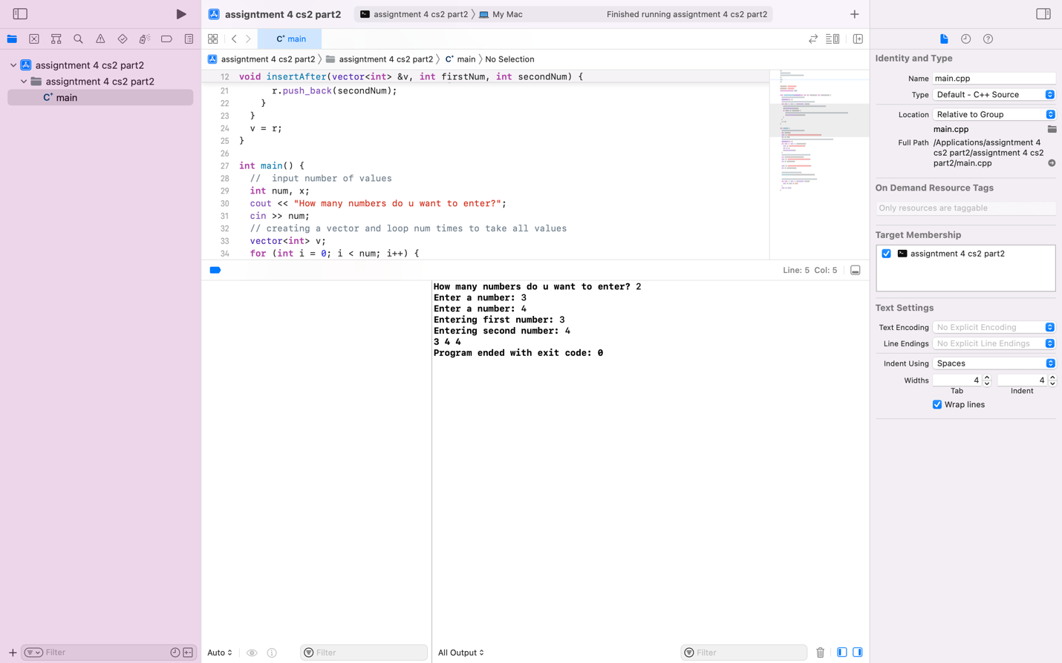

This program contains a class that implements a LinkedList, and it includes functions that add a node, remove a node, and display a node. In addition, a function that using a vector’s components shows the occurrences of a node in the LinkedList it created. Lastly, this program contains a function that sums all nodes.

